# 

**Introduction** **2**

**Debug Method** **2**

TicketDetailsValues 2

**Contract Interactions** **3**

**Reserve** **3**

**Confirm** **3**

Success Message for Confirmation 3

**GetTicket** **4**

**getTicketDetails** **4**

**CancelByCustomer** **5**

CancelOperation (After 96 Hrs of departure) 5

TicketDetails 5

CancelOperation (Within 24 Hrs of departure) 5

TicketDetails 6

**Airline Updates** **6**

Flight Cancellation 6

CancelFlight 6

Ticketdetails 7

Claim (by customer) 7

Ticketdetails 7

Flight Delay 7

FlightDelay – 12 hrs 8

Ticketdetails 8

Claim (by customer) 8

Ticketdetails 8

FlightDelay – 2 hrs 9

Ticketdetails 9

Claim (by customer) 9

Ticketdetails 10

Flight On time 10

FlightOntime 10

Ticketdetails 11

Claim (by customer) 11

Ticket details 11

**No Update By Airline** **12**

**ConfirmTicket** **12**

Ticket Details 12

Claim 12

TicketDetails 12

**Negative Scenarios** **13**

Error Message in case of wrong requestor: 13

Airline Trying to confirm 13

Customer Trying to delay 13

Error Message in case of insufficient balance 13

# 

# Introduction

This document contains screenshots for various actions in the Blockchain Capstone Project.

# 

# Debug Method

## TicketDetailsValues

This is a general method provided to know the details for a ticket. An example output along with values of the state is given below:

enum TicketState {RESERVED, CONFIRMED, CANCELLED, CLAIMED}

enum FlightState {ONTIME, DELAYED, CANCELLED, SCHEDULED}

"0": "address: 0x5B38Da6a701c568545dCfcB03FcB875f56beddC4", – > Airline Address

"1": "address: 0xAb8483F64d9C6d1EcF9b849Ae677dD3315835cb2", – > Customer Address

"2": "uint8: 3", – > Ticket Status

"3": "uint8: 3", – > Flight Status

"4": "uint256: 100", – > Ticket Price

"5": "uint256: 100", – > Refund to customer

"6": "uint256: 0", – > Payment to Airline

"7": "string: Ticket claimed by customer" – Ticket Status

# Contract Interactions

## Reserve

This is a method provided to book a ticket for a customer.

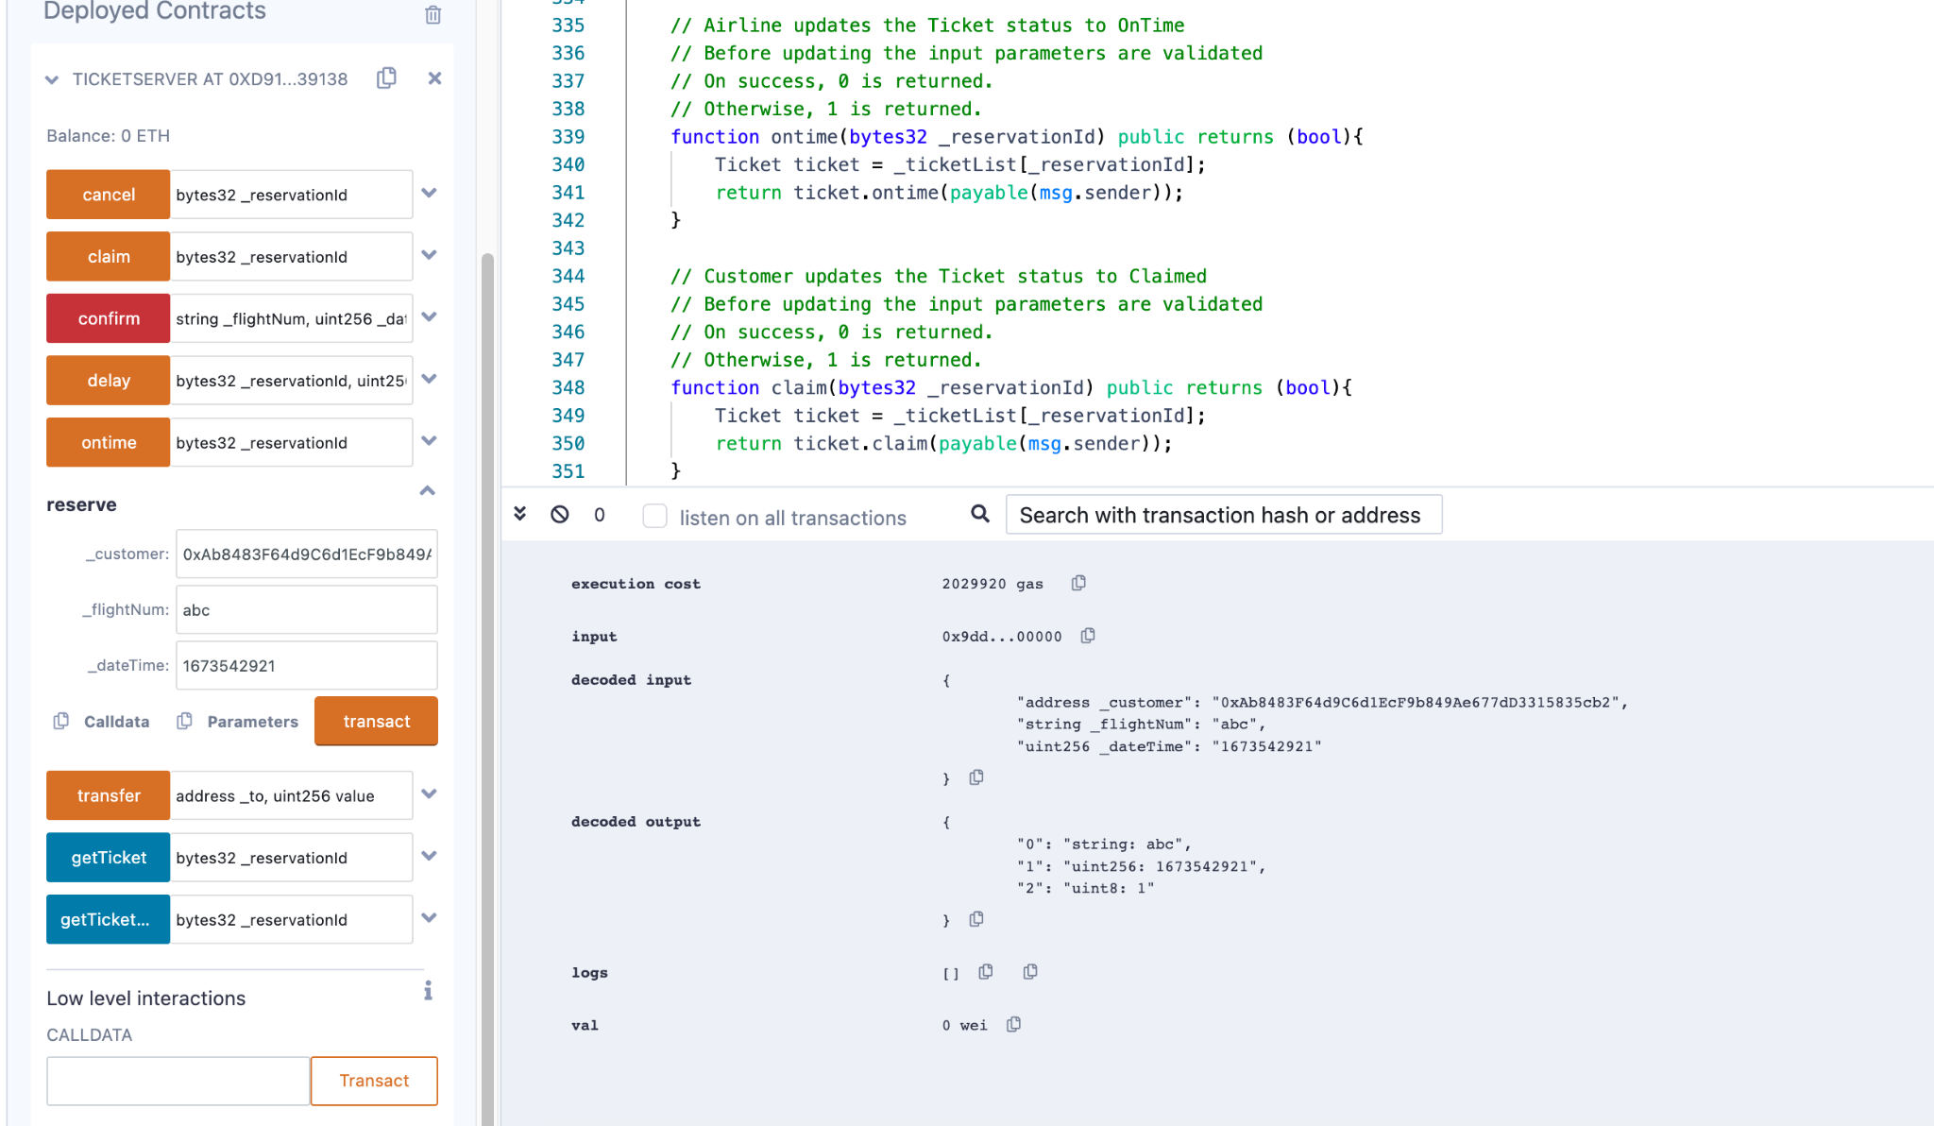

## Confirm

This is a method provided to book a transfer money from customer account to contract.

### Success Message for Confirmation

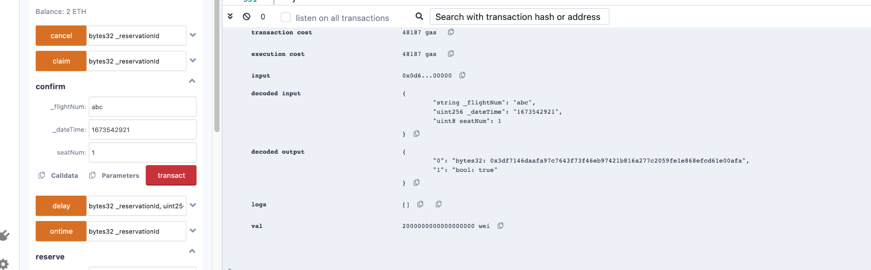

### GetTicket

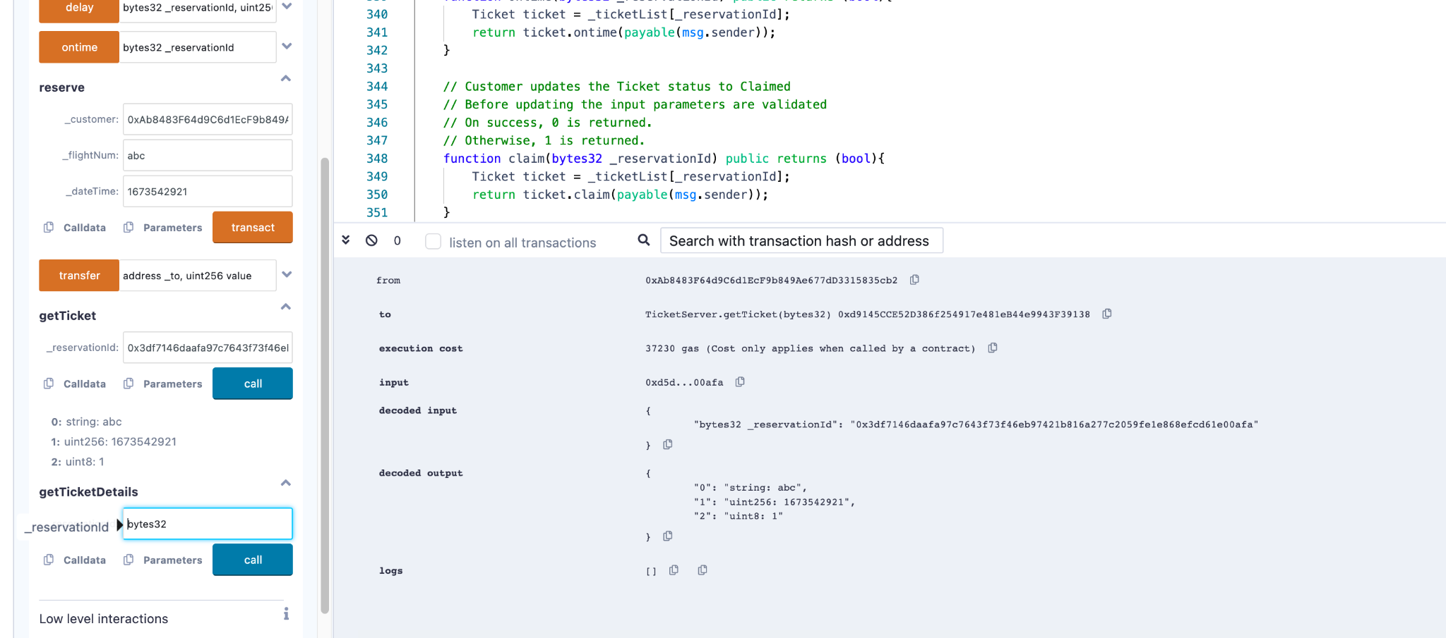

### getTicketDetails

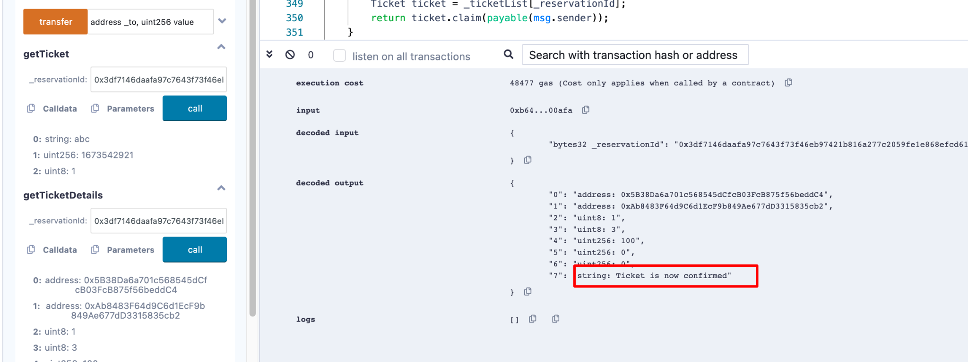

## CancelByCustomer

### CancelOperation (After 96 Hrs of departure)

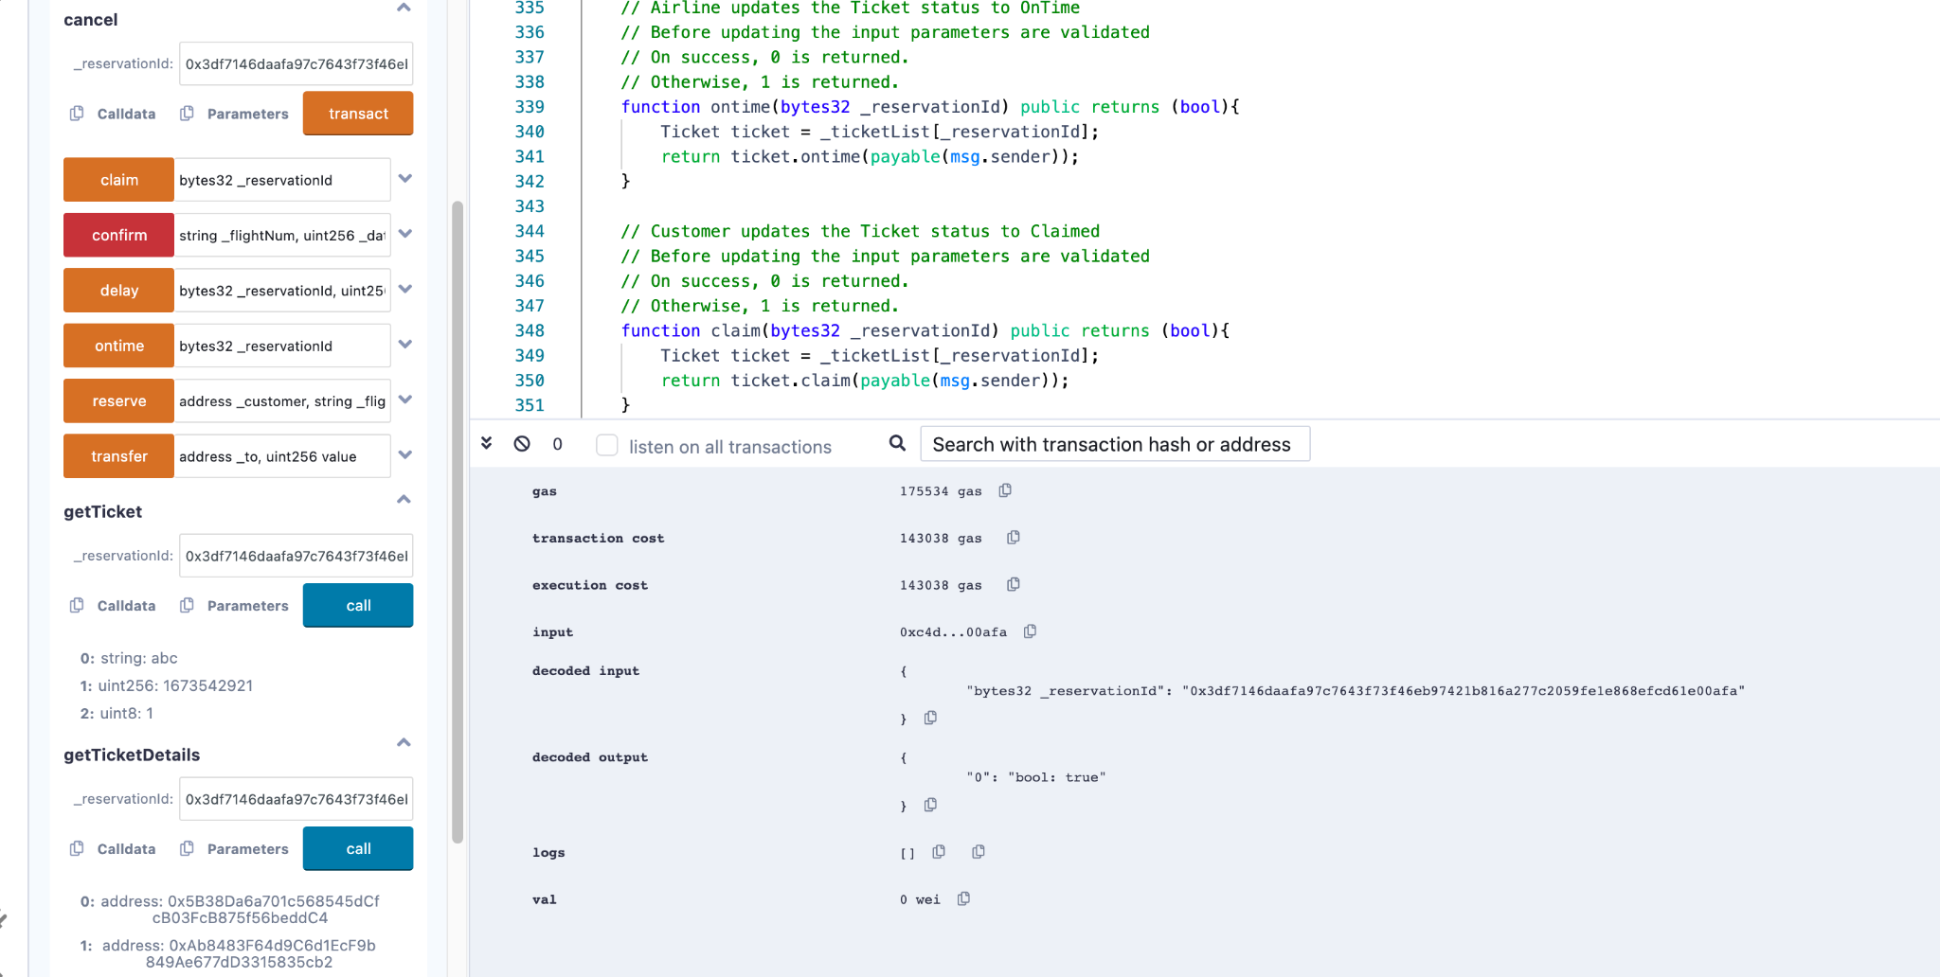

#### TicketDetails

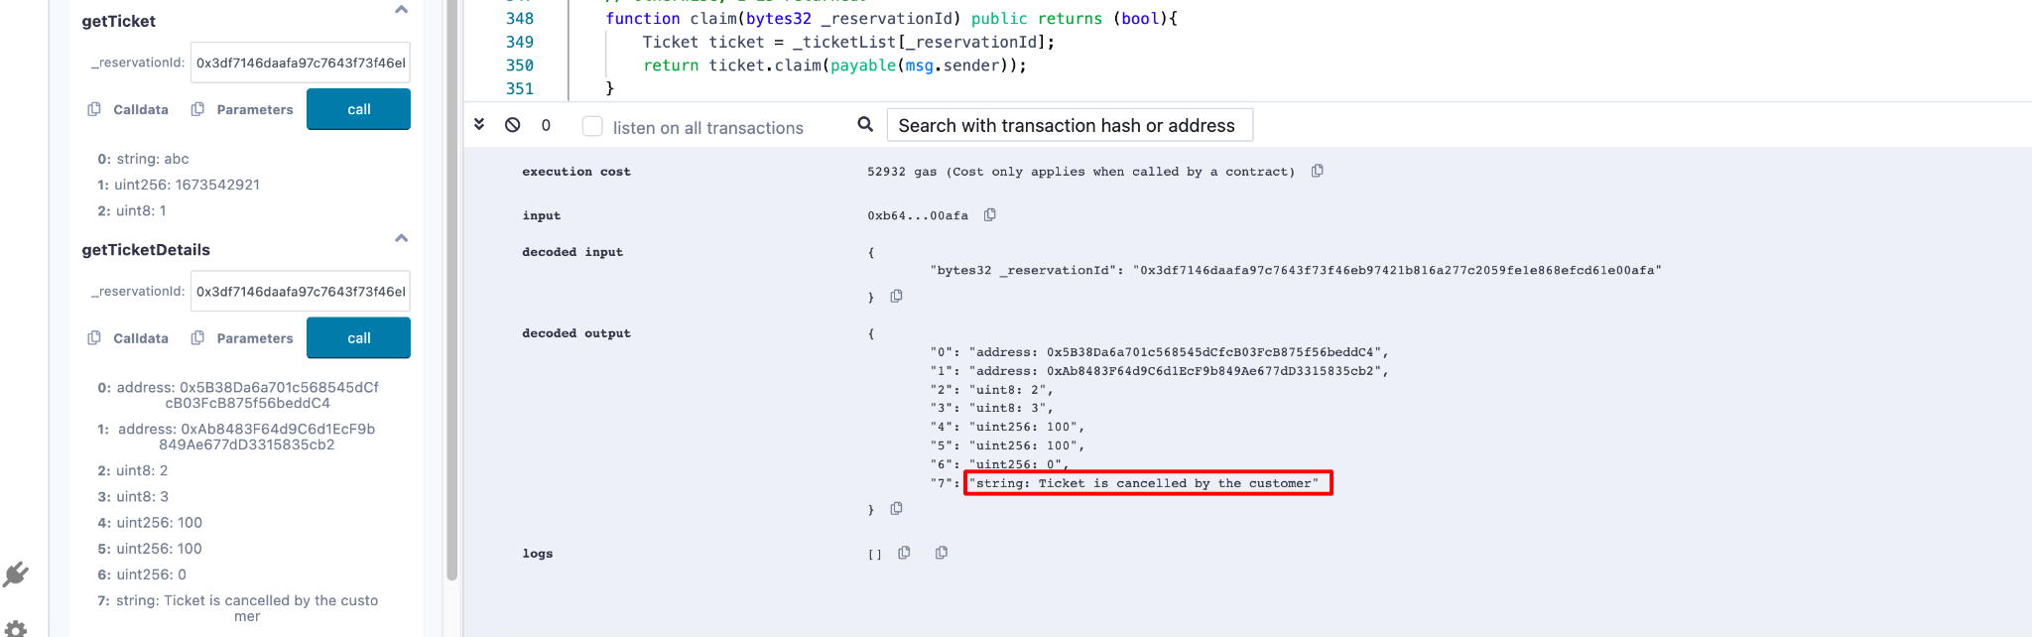

### CancelOperation (Within 24 Hrs of departure)

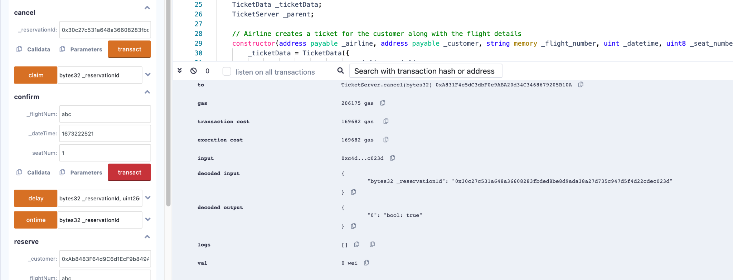

#### TicketDetails

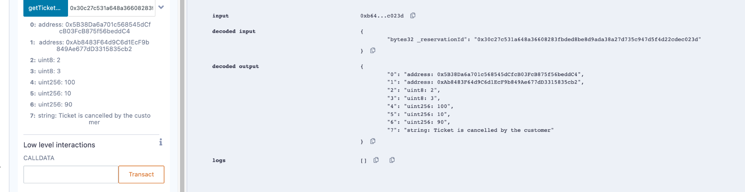

## Airline Updates

### Flight Cancellation

#### CancelFlight

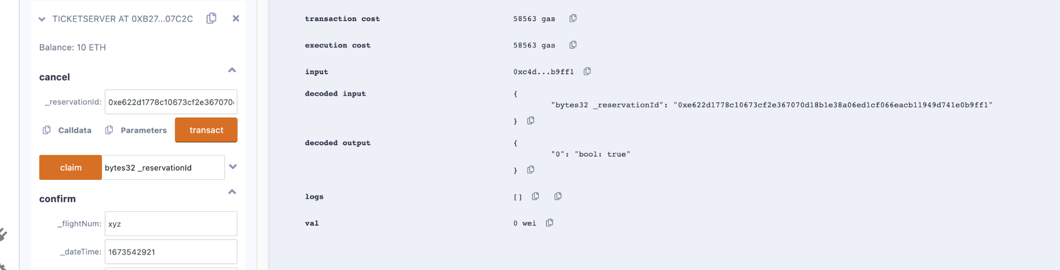

#### Ticketdetails

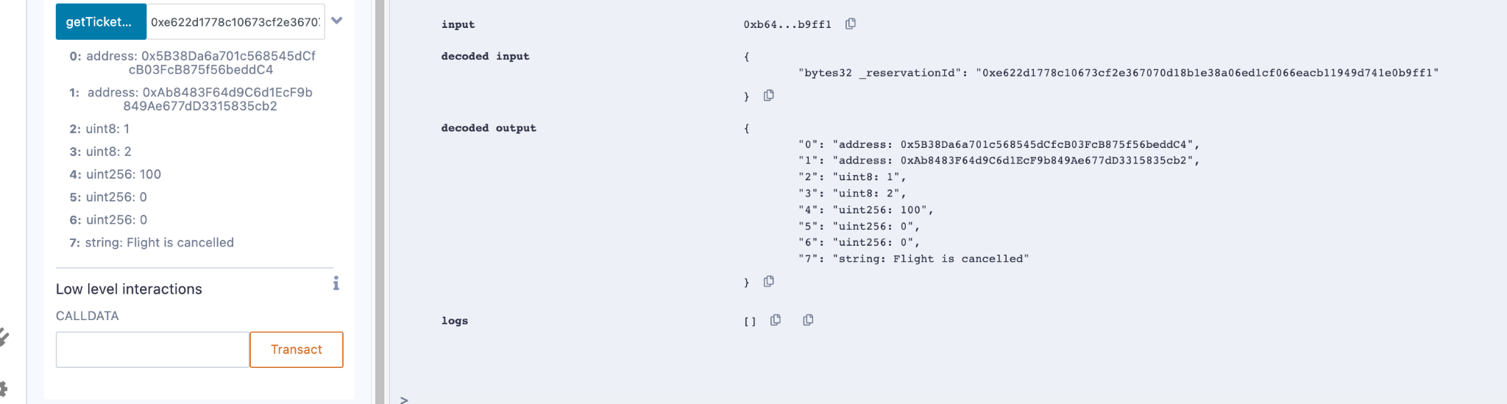

#### Claim (by customer)

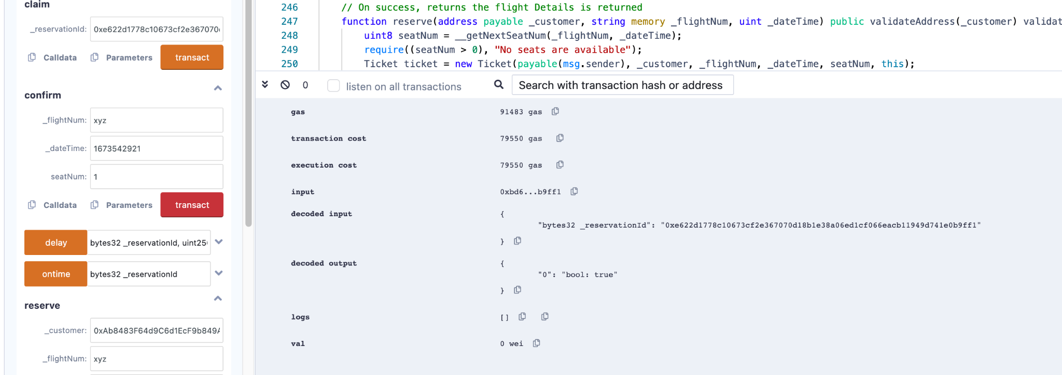

#### Ticketdetails

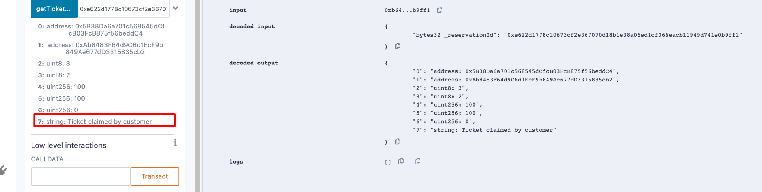

### Flight Delay

#### FlightDelay – 12 hrs

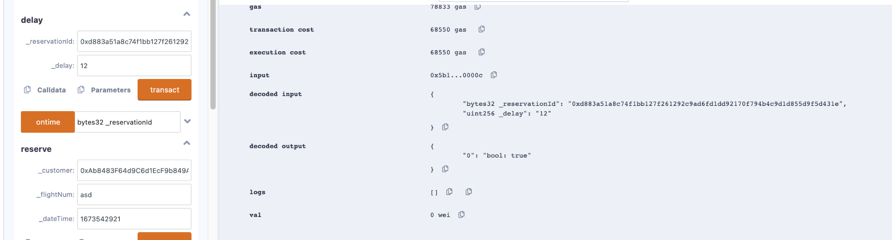

##### Ticketdetails

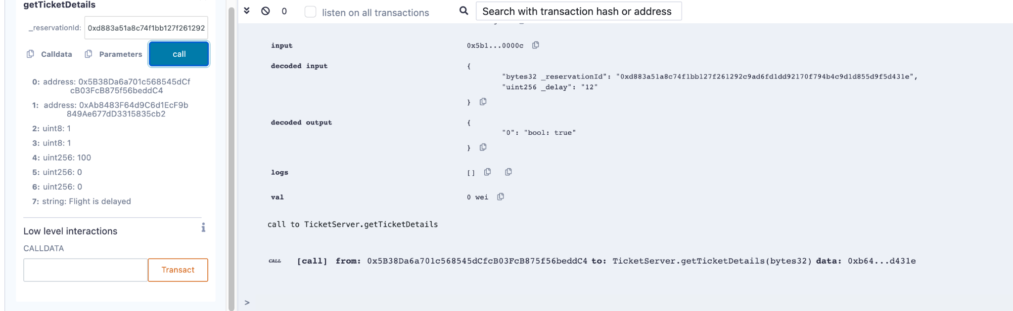

##### Claim (by customer)

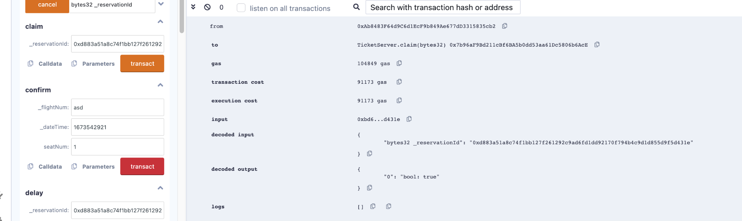

##### Ticketdetails

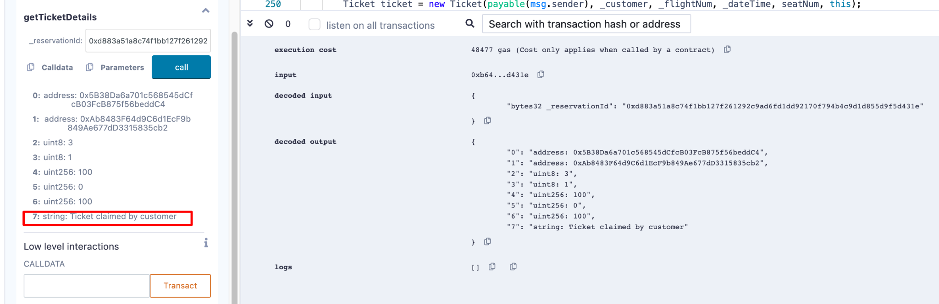

#### FlightDelay – 2 hrs

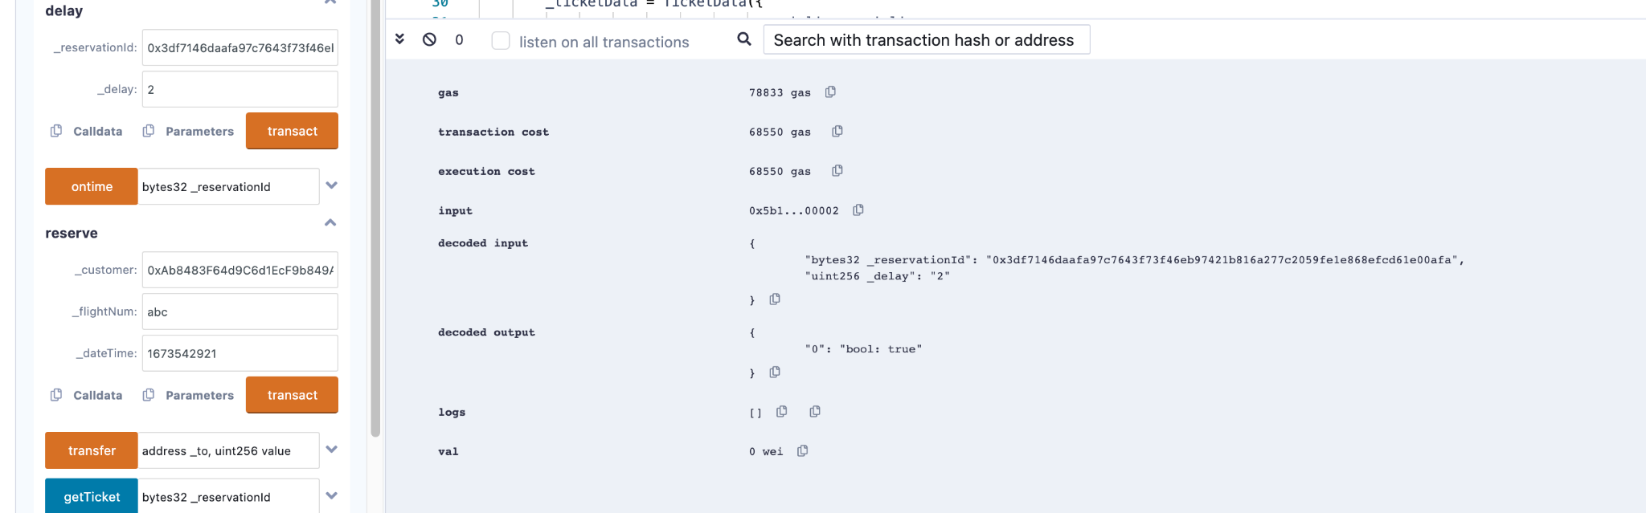

##### Ticketdetails

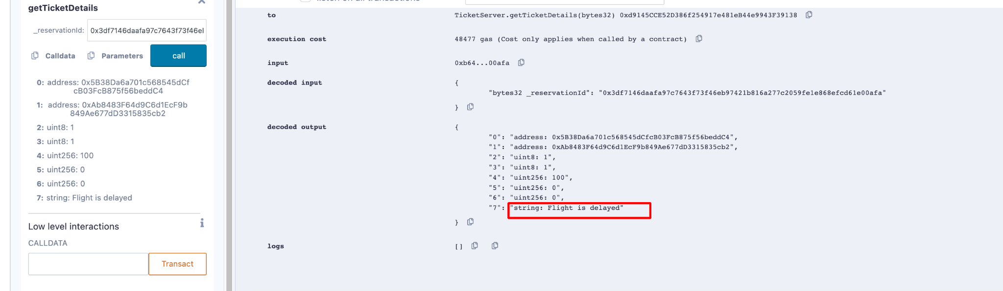

##### Claim (by customer)

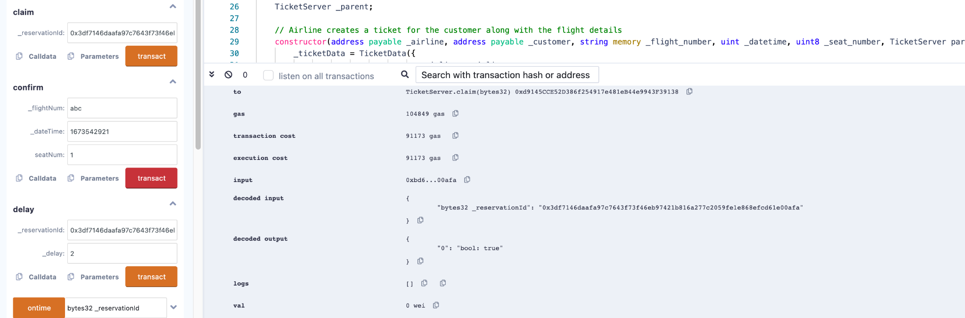

##### Ticketdetails

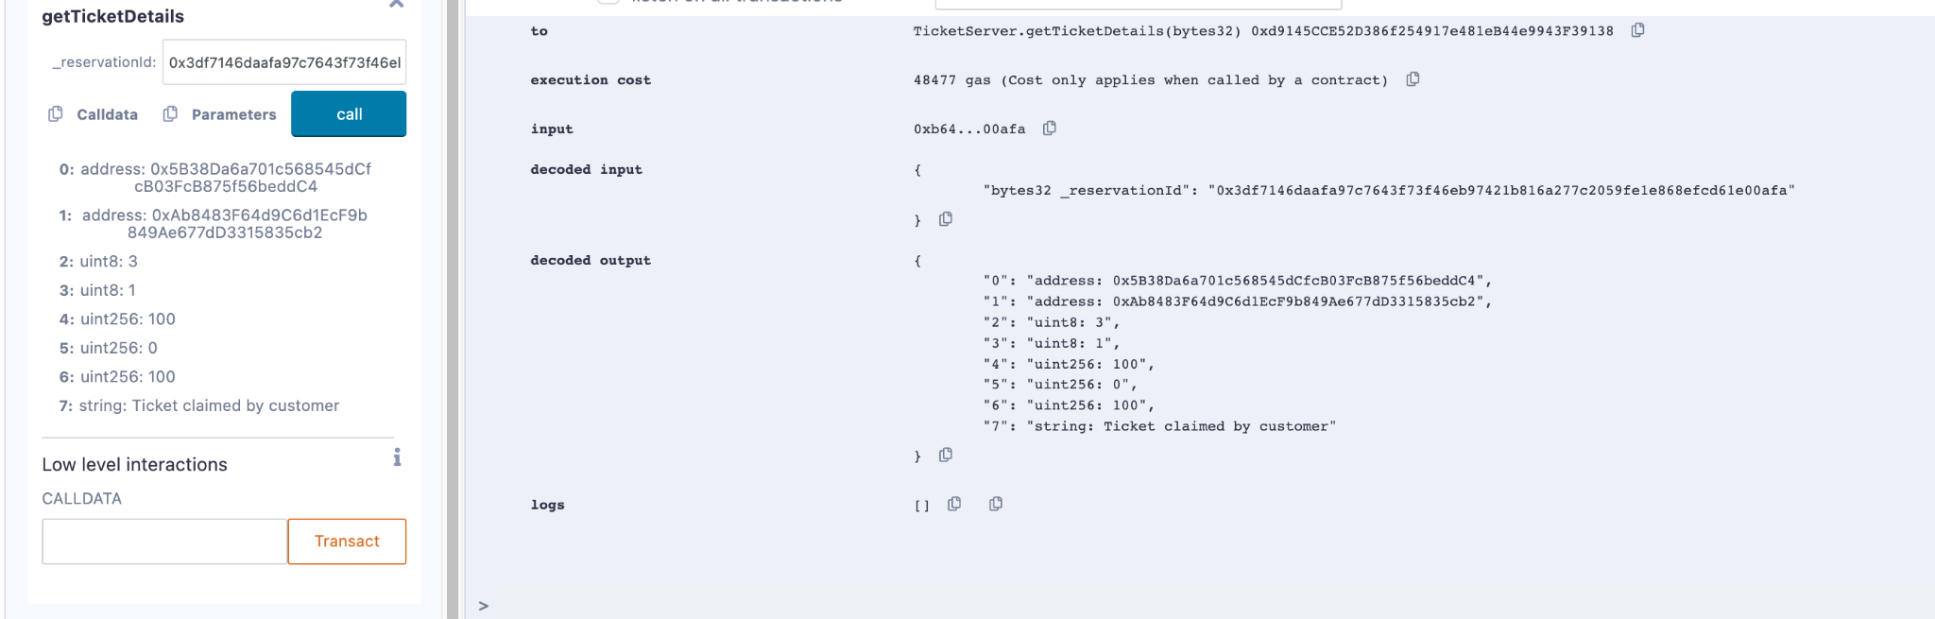

### Flight On time

#### FlightOntime

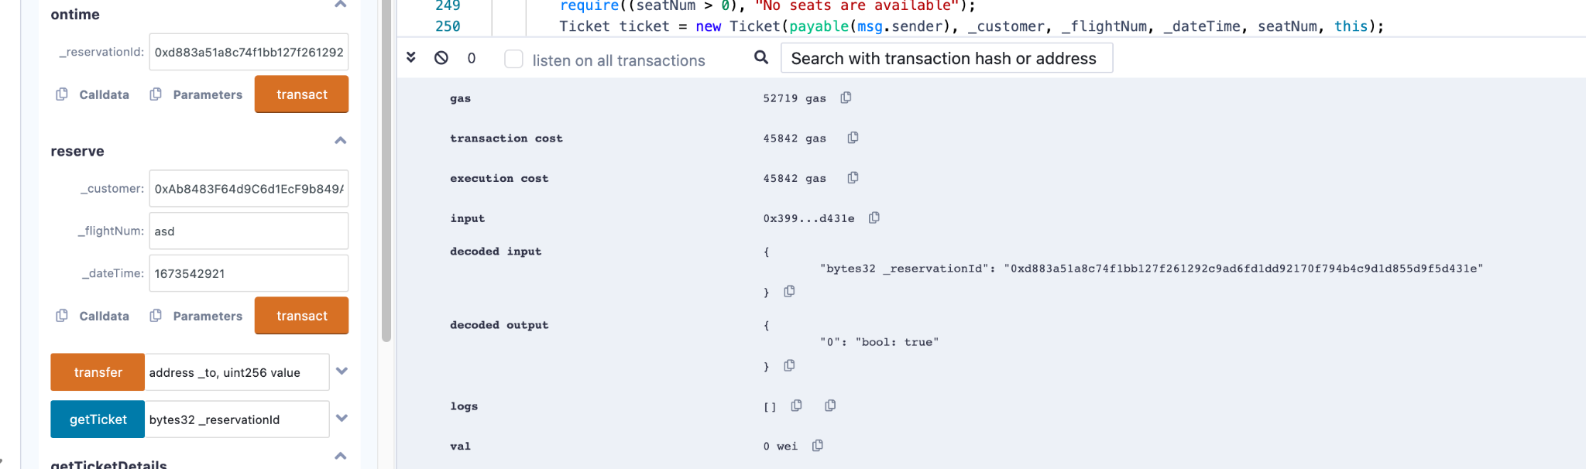

#### Ticketdetails

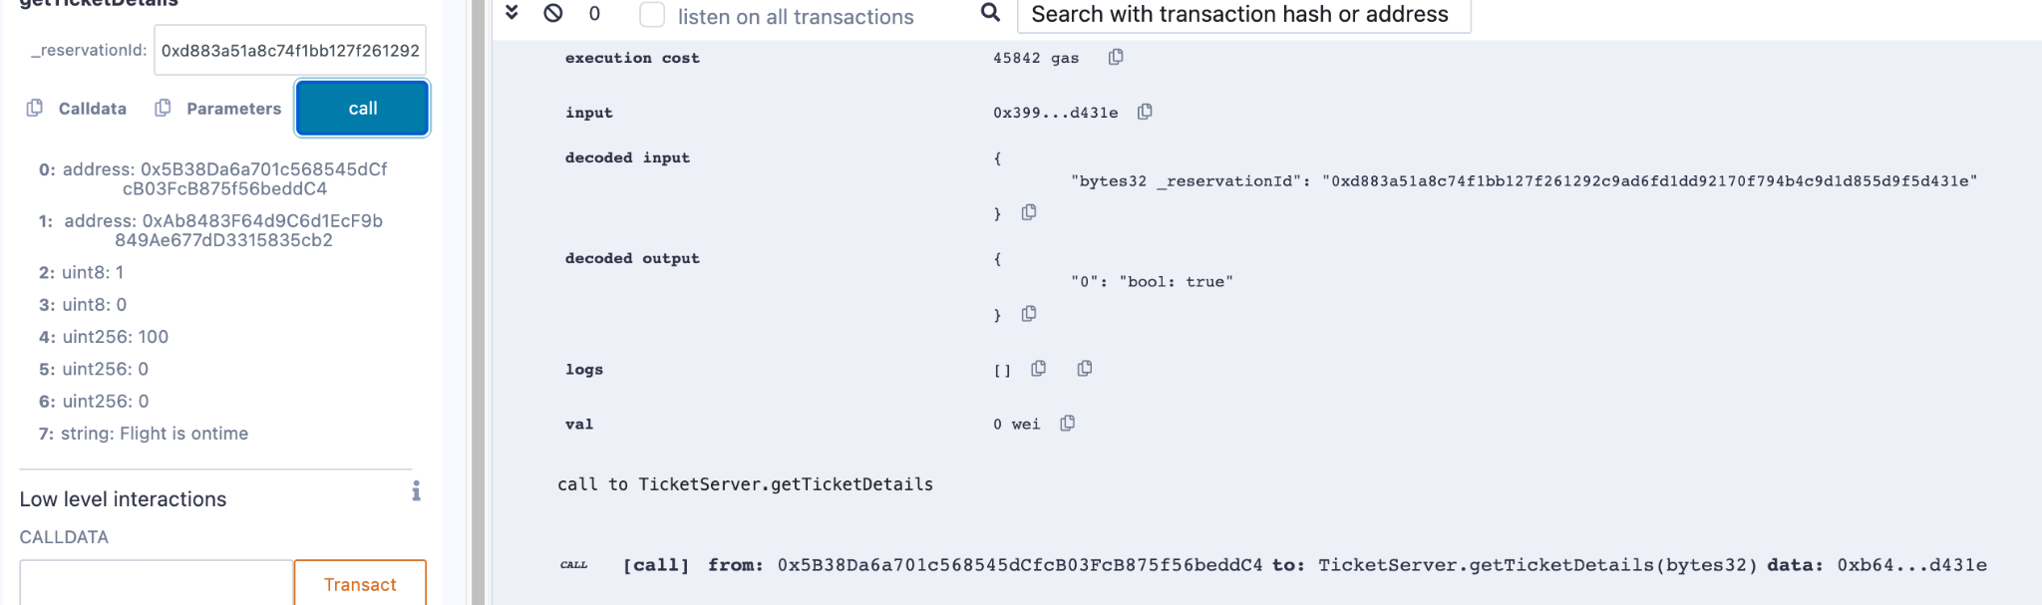

#### Claim (by customer)

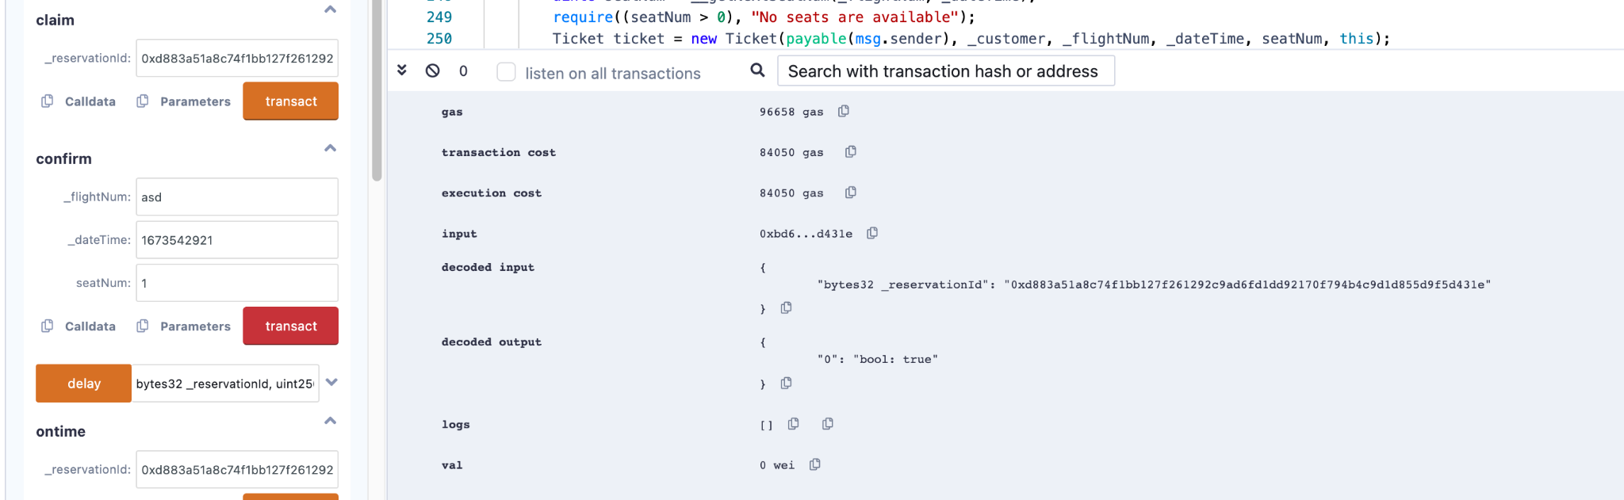

#### Ticket details

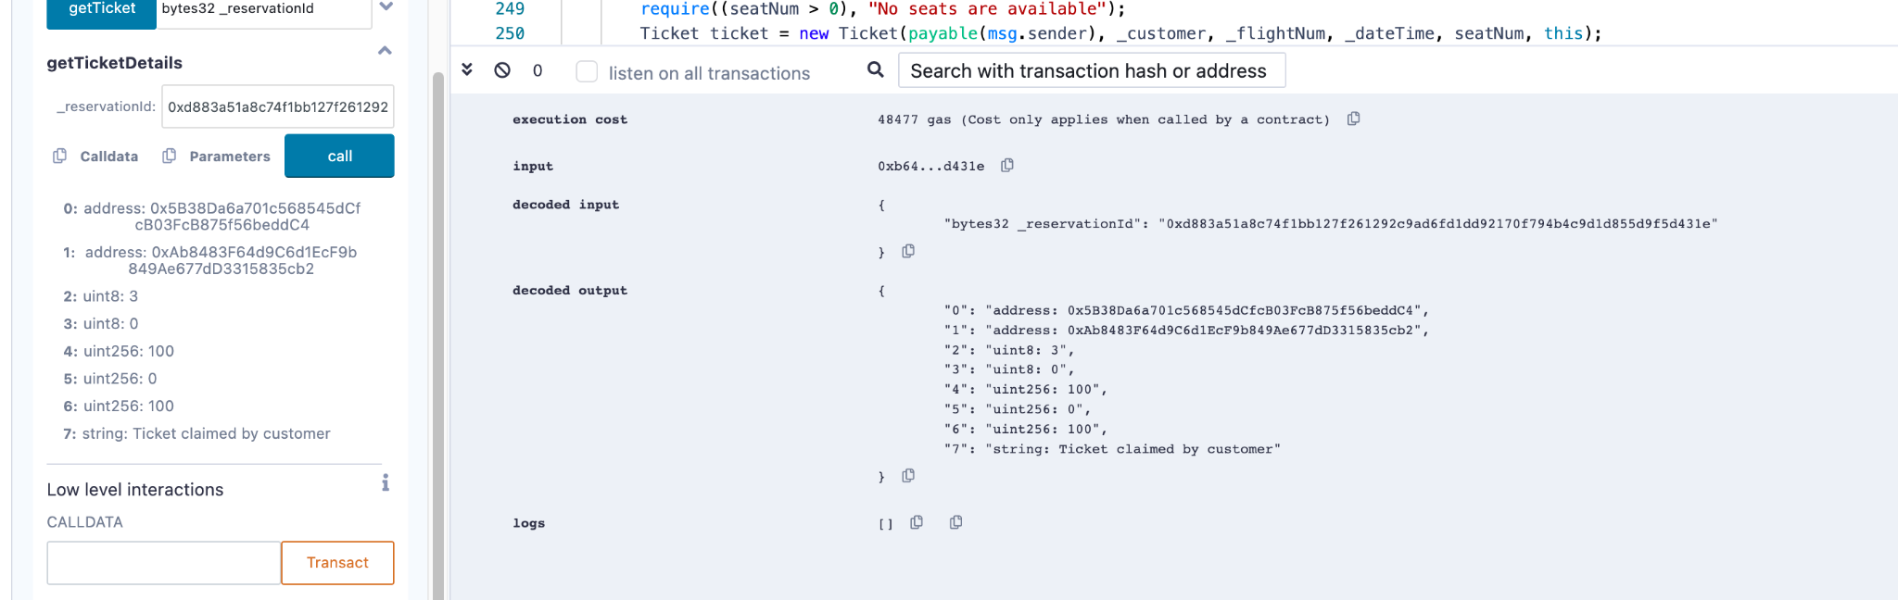

## No Update By Airline

### ConfirmTicket

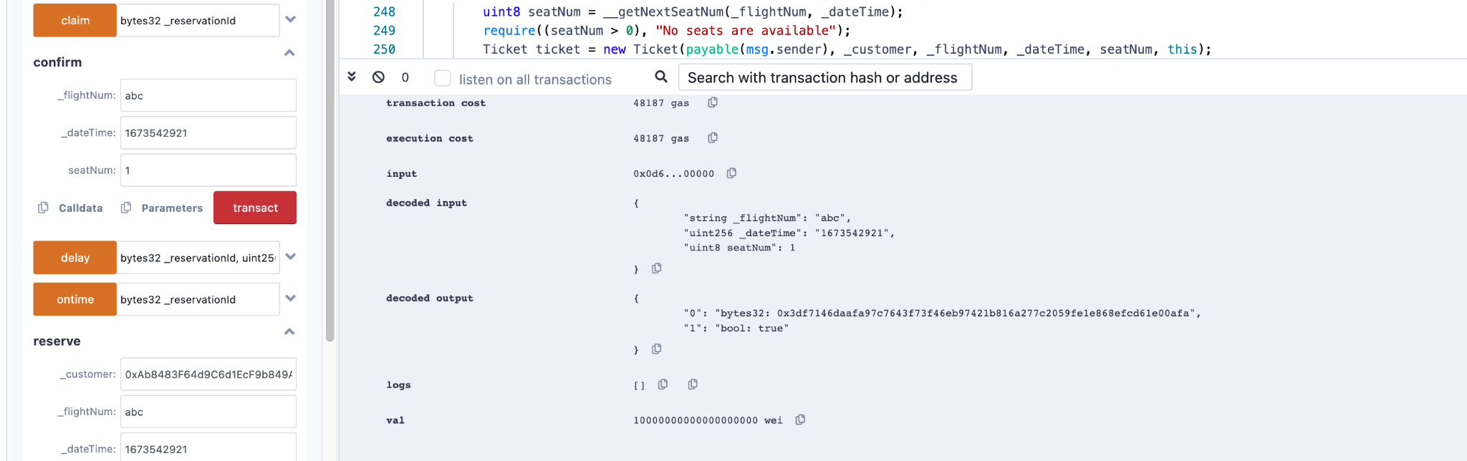

### Ticket Details

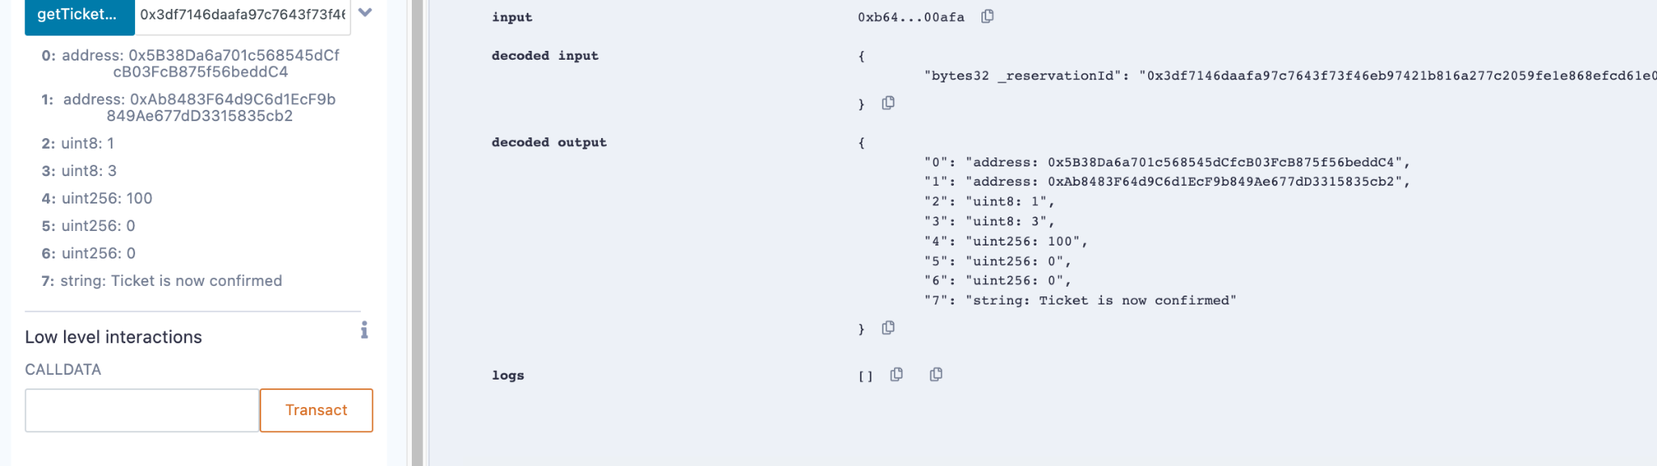

### Claim

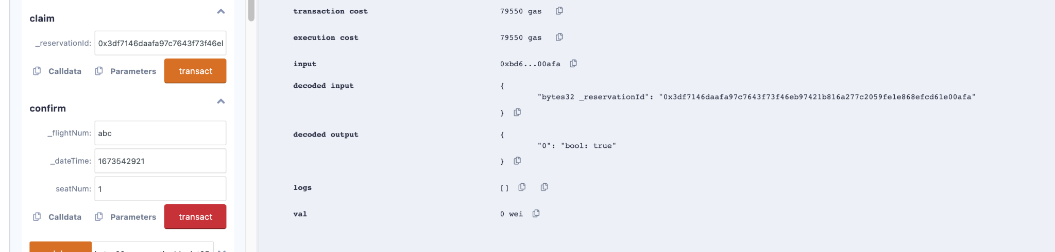

### TicketDetails

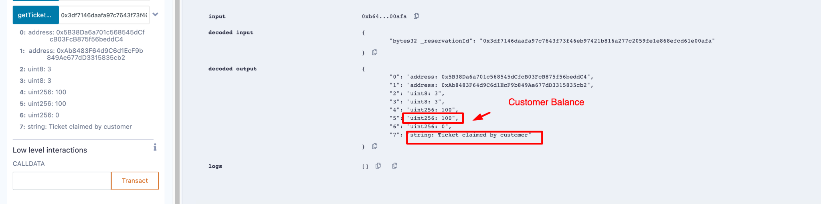

## Negative Scenarios

#### Error Message in case of wrong requestor:

Sample output is provided for a wrong requestor. This works in all cases.

##### Airline Trying to confirm

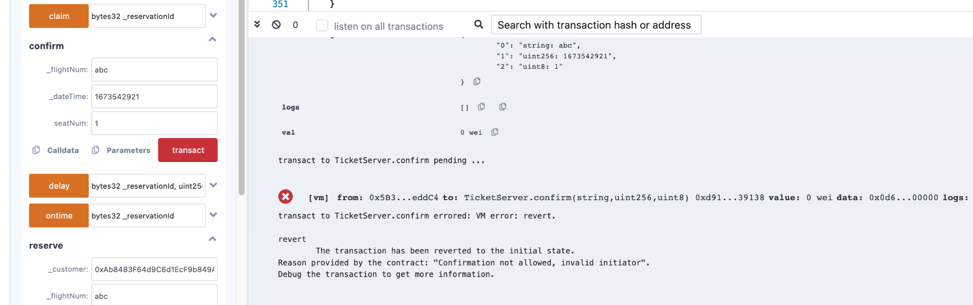

##### Customer Trying to delay

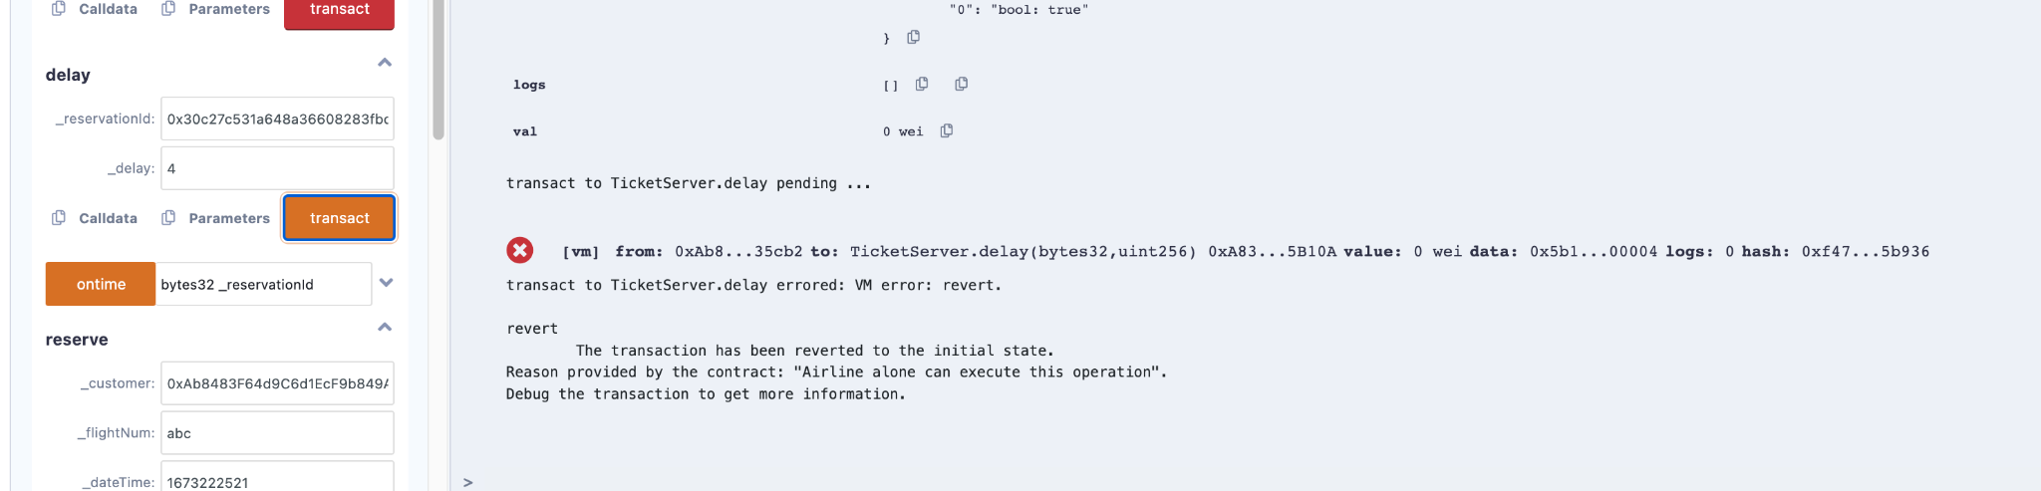

### Error Message in case of insufficient balance

